Research on the Impact of R&D Expense Deduction Policy on Human Capital Structure of Manufacturing Enterprises

Jun Liu1*, Richard King², Hao Zhang¹
1 Xi'an University of Finance and Economics, Xi'an, Shaanxi, China
2 The University of Melbourne, Melbourne, Australia
*Corresponding Author

Abstract: In the current tax incentive landscape, the accelerated depreciation of R&D expenses stands as a paramount policy tool in boosting manufacturing firms’ investment in human capital. This study employs a sample of Chinese A-share man- ufacturing listed companies from 2013 to 2022, treating the 2018 R&D expense deduction policy as an exogenous shock. The analysis initiates with a common trend test, followed by adifference-in-differences (DiD) model for the main effect regression, focusing on the mediating role of R&D expenditure in the policy’s impact on the firm’s human capital structure. For state-owned enterprises and those with concentrated capital, efforts should be made to enhance human capital structures through measures like increasing employee mobility and creating favorable working environments. Companies should collaborate with universities to tailor high-skilled, high-education talent development programs that align with their needs and institutional objectives. Offering internship opportunities to students can help prepare them for future employment, ensuring they are familiar with the business processes of the enterprise before entering the job market.

Keywords: tax incentives, manufacturing firms, human capital structure, difference-in-differences (did) model

1. Introduction
Currently, Chinese manufacturing enterprises are experiencing a slowdown in growth and face issues such as the need for further optimization of their internal human capital structures. To address this situation, tax incentive measures such as additional deductions for R&D expenses can be implemented. By reviewing relevant domestic and international literature, a majority of scholars, such as Ma Fan (2023)[1], argue that the policy of additional deductions for R&D expenses is a special provision established by the government aimed at encouraging companies to increase their investment in R&D and support technological innovation. Studies by Guceril et al. (2019)[2] indicate that when companies benefit from tax reduction incentives, their investment behavior is significantly stimulated.

2. Research hypotheses
Duguet (2012)[3]found that additional deductions for R&D expenses can compensate for the costs of hiring high- skilled talent, further incentivizing increased R&D investment and encouraging companies to hire more high-tech R&D personnel. Dai Tianxi (2022)[4] argues that the manufacturing sector, with its significant tangible assets, requires higher levels of skilled human capital. To achieve competitive advantage through independent R&D innovation, manufacturing firms must employ specialized high-tech talent. Therefore, increasing the R&D deduction for manufacturing firms could indirectly influence their human capital investment behaviors, alleviating conflicts between self-interest and altruism in such investments. This would positively impact the optimization of the human capital structure in manufacturing firms. Thus, this study proposes the following hypothesis:

3. Research design
This paper adopts the double-difference model as the main effect model, and takes the 2018 R&D expense deduction policy as an exogenous shock. The details are as follows:
(1)

4. Empirical analysis

4.1 Descriptive stats
Regarding the explanatory variable, the policy shock (Treat×time), the maximum value is 1, and the minimum is 0, indicating a notable difference in the intensity of the policy impact across the sample firms. The mean of this variable is 0.162, with a standard deviation of 0.369, which implies that the level of policy impact is generally low across the firms in the sample Table 1.
Table 1. Results of descriptive statistics
 | COUNT | MEAN | MIN | SD
Rdr | 21171 | 16.477 | 0.350 | 13.585
Medu | 21171 | 29.887 | 0.000 | 22.408
Treat× time | 21171 | 0.162 | 0.000 | 0.369
Size | 21171 | 22.189 | 19.887 | 1.265
Lev | 21171 | 0.397 | 0.051 | 0.196
Roa | 21171 | 0.045 | -0.235 | 0.069

4.2 Parallel trends test
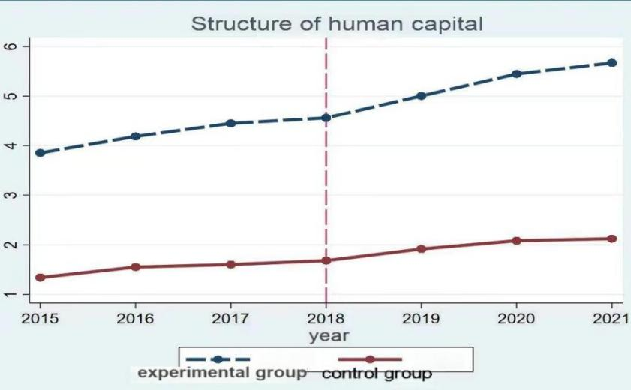
Figure 1. Parallel trend test
Building on the methodology proposed by Liang Fushan and Wang Xijie (2023)[10], the enterprises were categorized based on their industry’s average size. As detailed in Column (10) of Table 7, which focuses on small-scale manufacturing enterprises, and Column (11), which pertains to large-scale manufacturing enterprises, the results indicate that the coefficient of the policy shock in 2018, represented by the interaction term `Treat × time`, is 0.4488. This variable is found to be statistically significant at the 5% level. This finding suggests that the policy shock in 2018 was effective in enhancing the human capital structure of small-scale manufacturing enterprises Figure 1.

5. Conclusion
In summary, with the rapid development of technology, especially the wide application of artificial intelligence, big data, blockchain and other emerging technologies, the field of tax collection and administration is experiencing unprecedented changes. In the future, the impact of technological trends on tax collection and management will become more and more significant. Therefore, while enjoying the convenience brought by technology, tax departments also need to strengthen information security protection and ensure the stable operation of the tax collection and administration system. Only in this way can they adapt to the needs of the development of the digital economy, improve the efficiency of tax collection and administration, safeguard the rights and interests of the national tax revenue, and promote the sustainable and healthy development of the economy.

Acknowledgments
This paper was supported by Shandong Province Traditional Chinese Medicine Science & Technology Project (No.M-2024008).

References
- Ma Fan. Discussion on the policy of additional deduction of R & D expenses for small and medium-sized enterprises [J]. Finance, 2023, (15): 51-53.
- Guceri I, Liu L. Effectiveness of fiscal incentives for R&D: quasi-experimental evidence[J]. American Economic Jour- nal: Economic Policy, 2019, 11(1):266-291.
- Duguet E. The effect of the incremental R&D tax credit on the private funding of R&D: an econometric evaluation on french firm level data [J]. Working Papers, 2012(03):405-435.
- Dai Tianshi, Zhao Qi. Innovation incentive policy and enterprise skill requirements — Evidence from the r & D expense additional deduction policy [J]. Financial Research, 2022 (03): 92-112.

中文说明
为了减少返修等环节耽误的时间，在送审稿件之前务必审核是否符合以下要求。（注：稿件的文件格式必须是doc./docx；全文不能出现中文）
（一）文章结构必须包括以下内容（一个部分都不能少）。
1. 标题Title：第一个单词的首字母和每个实词的首字母大写
2. 作者信息（要包含以下内容，必须保证准确无误）
（1）每个作者姓名（文章题目下方的署名（名在前，姓在后），注意确定作者数量），有多个作者时需明确作者顺序；（2）有多个作者时要标明通讯作者；（3）每个作者的单位名称及单位地址（单位所在城市+省份+国家等），一一对应；（4）本篇文章需要挂的基金项目或课题等（如果有），放在参考文献 References前面。不需要邮编和邮箱，单位地址顺序要由小到大，最后以国家结尾。
3. 摘要Abstract：100-200英文单词，不要分段，包括研究目的或范围、研究方法、最终结果和结论等。
4. 关键词Keywords：3-5个词，每个单词首字母小写，每个单词之间用半角逗号“, ”隔开。
5. 引言Introduction：包括研究背景、研究课题及重要性、陈述假设等。
6. 结论Conclusion：理论价值，实际价值，同已有的研究成果相对比有哪些优劣异同，做了哪些发展改进，研究中存在的尚未解决的问题，提出的相关建议与展望，等等。
7. 参考文献 References（要符合以下要求，本文档最后有示例）
（1）参考文献清单应仅包括正文中引用的、已出版或接受出版的作品。个人通讯和未发表的作品只应在正文中提及。不能用脚注或尾注代替参考列表。各级标题不得使用引文标示。
（2）必须在正文中的具体位置从[1]开始按顺序用方括号标出参考文献编号[1] [2] [3]…（不能有引用链接功能），与文末的参考文献列表相对应。
（3）文末的参考文献列表要用方括号从[1]开始按顺序排列[1] [2] [3]...，同一参考文献不能有多个编号，只能有一个编号（不能有引用链接功能）
（4）文章参考文献建议至少6条，如文章3页以内，文献可以3条左右。但是不能没有或只有1条文献。
（5）每条参考文献信息要完整、准确、格式标准统一，尤其是期刊名、书名、出版年份、卷数、期数、页码等。格式标准参考第（六）项之后的示例。
（二）文章须有各层级标题。需注意标题格式（只需第一个单词的首字母大写）：一级标题1. Xxx/2. Xxx/3. Xxx...，二级标题 1.1 Xxx/1.2 Xxx/1.3 Xxx...，三级标题1.1.1 Xxx/1.1.2 Xxx/1.1.3 Xxx...，以此类推。并且不同层级标题后面须有文字内容。
（三）如果文章含有图或表格，图下方必须有名称Figure 1. Xxx ，表格上方必须有名称Table 1. Xxx。且图片必须为嵌入式，不要飘着！（图片或表格一定要放在正文中的具体位置，不能统一放在文章最后）。
（四）文中不能出现脚注和有引用链接功能的上角标，可选择在正文中用括号注释或放在参考文献里，上角标必须是普通且没有引用链接功能的。
（五）正文图片中不能出现中文；图片、参考文献等部分不能出现中文。
（六）文章中的公式不能是截图或图片形式，要写成mathtype公式或者word自带的公式。
参考文献示例：
①期刊
[序号]作者名, 题目. 期刊名. 出版年份; 卷数(期数): 页码.
[1] Margerison, C.J. Interpersonal skills-some new approaches. Journal of European Industrial Training. 1998; 12(6):12-16.
②图书
[序号]作者名, 书名, 出版地点: 出版社; 出版年份.
[2] Simons NE, Menzies B, Matthews M. A Short Course in Soil and Rock Slope Engineering. London: Thomas Telford Publishing; 2001.
③学位论文
[序号]作者名. (发表年份)论文题目. Ph.D./ Master’s Thesis, 保存单位, 保存地.
[3] Giambastiani, B.M.S. (2007) Evoluzione Idrologica ed Idrogeologica della Pineta di San Vitale (Ravenna). Ph.D. Thesis, Bologna University, Bologna.
④网页/网址
[序号] 作者名. 文章名. Available from: 网址【保持超链接。如果此行放不下，采取强制断行放到下一行】[Accessed访问日期]
[4] European Space Agency. Rosetta: rendezvous with a comet. Available from: http://rosetta.esa.int [Accessed 15th June 2015].

